Assignment 3 Essay

To begin with , we create two t-distribution populations . Each has 1000 samples . We define first population as Empty 1 , while the second as Empty . They are both vectors , derived by i in 1:1000 . It is always known df for t_distribution should have a finite df . Once the df become infinite , it would become like standard distribution . To discuss this quation , we need to discuss central limit theory as well .

“*In probability theory, the central limit theorem (CLT) states that the distribution of a sample variable approximates a normal distribution (i.e., a “bell curve”) as the sample size becomes larger, assuming that all samples are identical in size, and regardless of the population's actual distribution shape*.”

As testing the distribution for normality , we use ad.test . We detect that P-values for both samples are 96.68% and 53.99% . It verifies that we fail to reject the hypertesting of normality , which is again compatible with central limit theory .

Table Normality testing

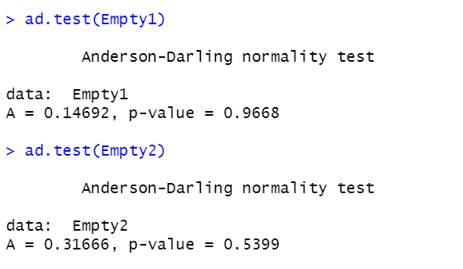

(Source: Author R Programming)

Figure 1 ggqqplot for Empty1

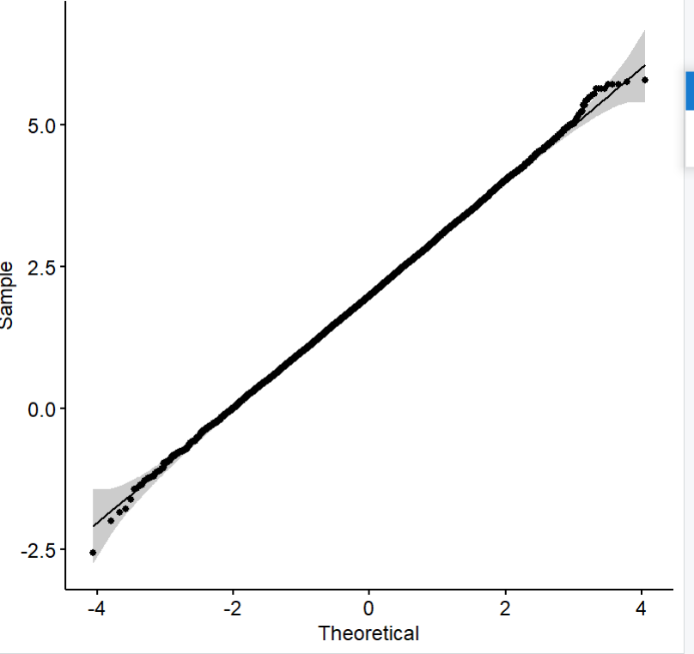

(Source: Author R Programming)

In this plot , we could see a almostly smoothed line except the two endings , which implies for date between (-3, 3 ) it is almost showing normal distribution . but for the two endings , it is a bit less like Noraml distribition , while the spots are more messy/ scattered .

Figure ggqqplot for Empty2

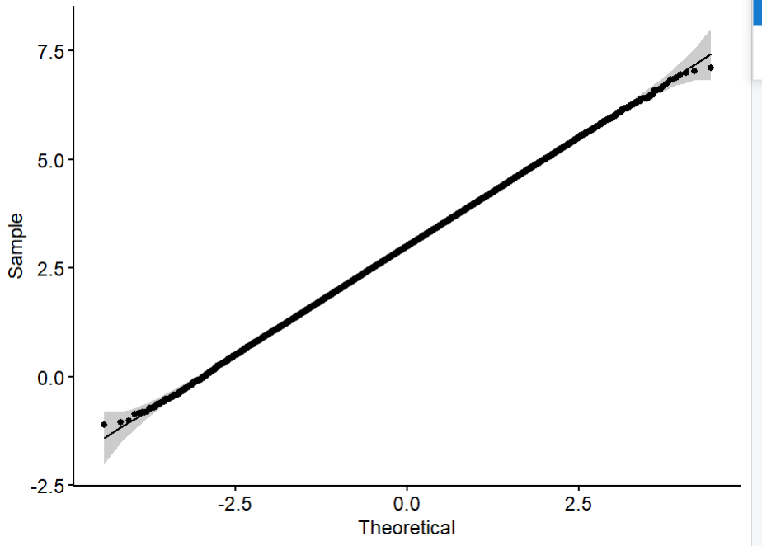

(Source: Author R Programming)

In this figure , we can detect a more regulative normal distribution of dataset compared to Empty1 . The two endings are more near to the staright line than Empty It is because Empty 2 has bigger sample size , so that it can be more near to normal distribution .

Figure Empty 1

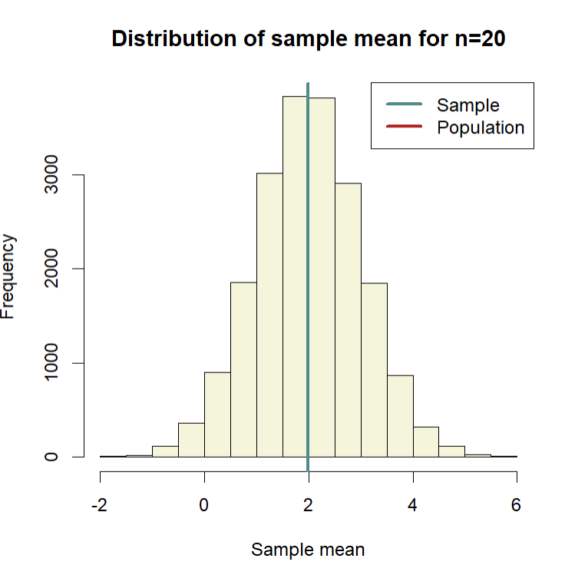

(Source: Author R Programming)

Figure Empty2

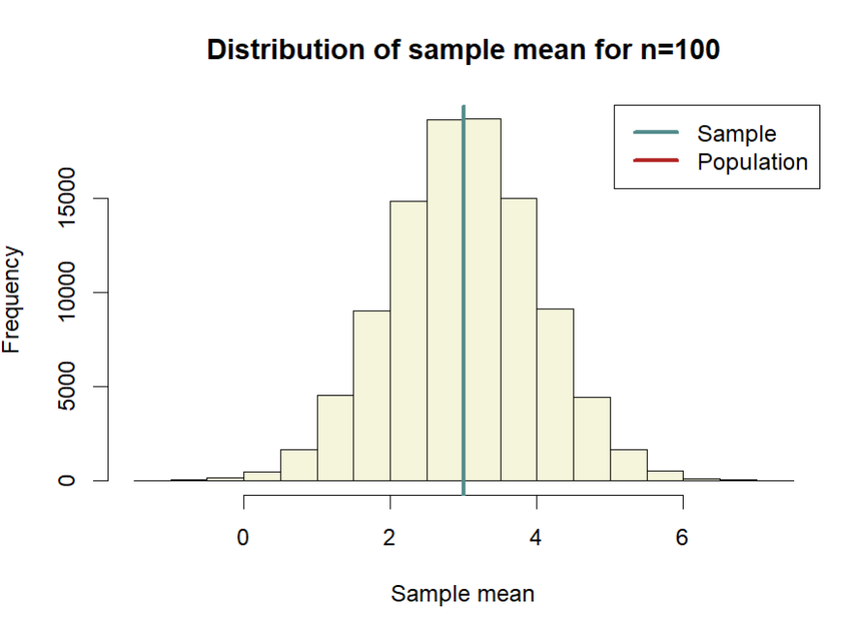

(Source: Author R Programming)

For empty 1 and 2 , we can have a good understandingbof how the sample mean and population means converge with each other , and how the sample means would be near to normal distribution , as central limit theory told us . From the shape of distribution for mean of Empty1 and of Empty 2, It is verified more , that the bigger sample size it is , the attribution of being as a normal distribution would be more obvious .